CHOCOLATE CHIP MUG COOKIE
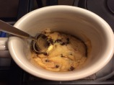

INGREDIENTS
  - 1 tablespoon butter
  - 1 tablespoon white sugar
  - 1 tablespoon brown sugar, packed
  - 1/8 teaspoon vanilla
  - 1 pinch salt
  - 1 egg yolk
  - 3 1/2 tablespoons flour
  - 1 tablespoon semi-sweet chocolate chips

DIRECTIONS
- Melt butter in microwave. Add sugars, vanilla, salt, egg yolk and stir. Add flour, mix well until fully combined. Stir in chocolate chips. Microwave for 30-50 seconds depending on your microwave wattage.

